# First Things First:

Download PyCharm: (For Windows, Community version)

<https://www.jetbrains.com/pycharm/download/#section=windows>

Download Python: (Windows x86 executable installer)

<https://www.python.org/downloads/release/python-374/>

You will need IT for the admin password!!!

# Setting up:

1. Open up PyCharm. The way I normally get to it is by searching. 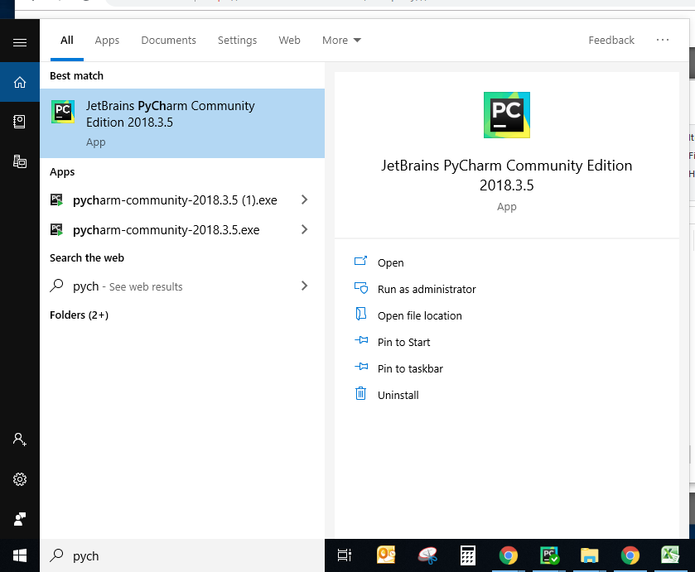
2. Within PyCharm select “New Project”. If you don’t have any projects, it should be easy to find in the first window. If you have other projects you need to go File -> New Project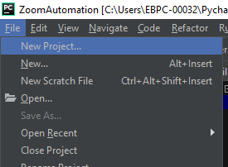
3. Name the project what you want. It will set up itself, which will take a minute.
4. Download the contents of the “Automation Programs” folder. (except for the “Training Docs” folder.) If you select all the files at once, it should download them into a zip file.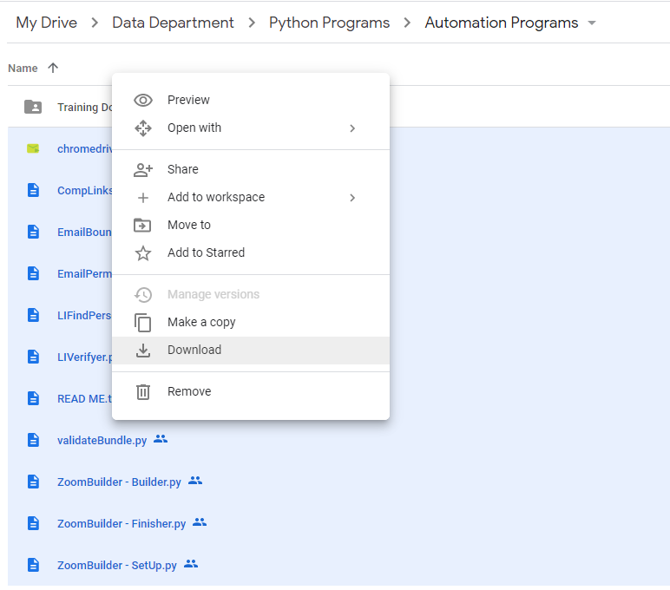
5. Once the zip file is downloaded, you should be able to extract it into the project folder.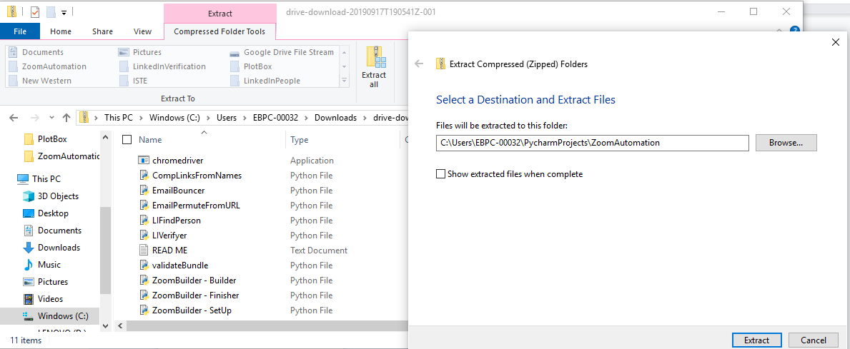
6. Now, if you go into the PyCharm project you should see all of those files in the project. I would suggest going through and opening each of the .py files.
7. You will now need to install the libraries that the project needs. Click into the terminal, then type “pip install [library name]” for each of the following:
   * selenium
   * bs4
   * py3dns
   * lxml
   * validate_email
   * tqdm

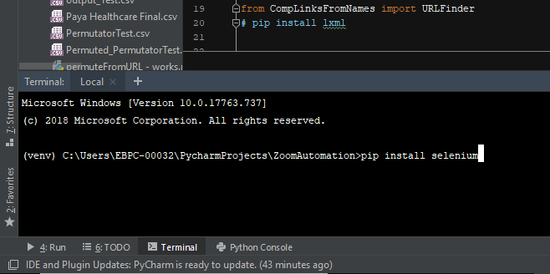

1. You are now ready to run the programs.

# To run any PyCharm program:

1. Put any .csv files you want to run into the project folder - Everything that needs to be run MUST be in the main project folder. If you want things to be clean and organized, make files for the .csv files and move them out as you need them.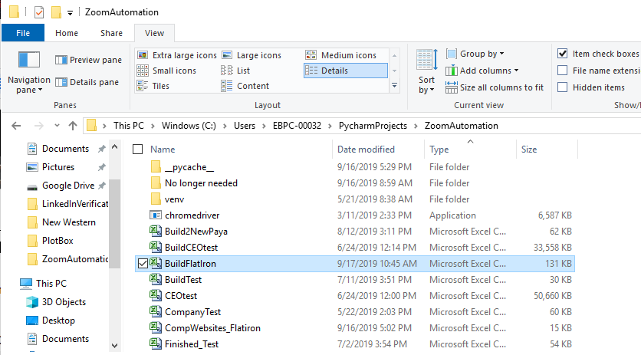
2. Open up PyCharm
3. Open up your project

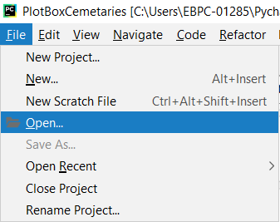

1. Open the .py file in pycharm and make sure it is your active window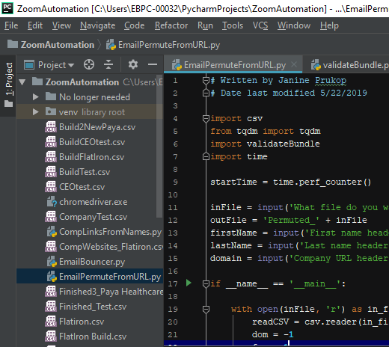
2. Go to Run -> Run

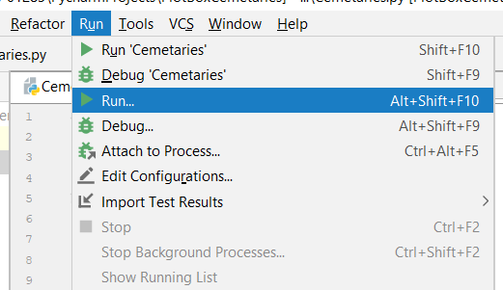

1. Select the program that you want to run (You will need to have opened it in PyCharm to select it)

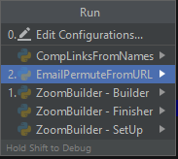

1. Input any information that the program asks for.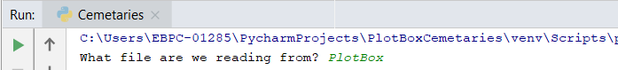
2. You can minimize the window while it works, or leave it up on your second monitor to watch it work while you work.
3. If it crashed or ran into an error there will be a lot of angry looking red text. Under normal circumstances, I would say to come find me (Janine), but I’m fixing this up for when I leave, so either make a sacrifice to the angry computer deities, up your google-fu game, or complain at the higher-ups that you guys either need to hire someone who understands Python or I need to be contracted as tech support for the python programs. (In all seriousness, you will probably be able to read the error message and it will tell you what is wrong. If it is a small/common error like you spelled something wrong in the input, it should be stated clearly enough to at least tell you where to look)